Joshua Pollock

CS 200 Project 1

February 3, 2017

Joshua Pollock

CS 200

Project 1 – Three Bit Adder

February 3, 2017

Purpose:

The task of this project is to create a 3-bit adder. Instead of creating a circuit with 64 combinations, I will be creating a 1-bit full adder that takes in X, Y, and Cin. This 1-bit adder will have two outputs of Sum and Cout. Three of these 1-bit adders will be chained together, with the carry out of the previous circuit connected to the carry in of the next. A truth table showing all the combinations will be created and a non-minimized Boolean function will be created for each output of the truth table. From here a K-map will be created and will clearly show the resulting minimized functions. I will only be allowed to use AND, OR, and NOT gate.

Research:

I had no idea where to begin with this problem. I began by starting to consider pictures of various adders in logisim. The most helpful website I found was of a [PDF from Harvey Mudd College](https://www.cs.hmc.edu/~cs5grad/MyCS/2013/Logisim.pdf). They describe how adders work and show examples of adders. This gave me an idea of where to begin with my adder.

Truth Tables:

Below are the truth tables I created. It shows all the AND operations followed by the long OR operation. These tables were verified by logisim, and caught an error within my logisim wiring (Two YCin’s and no XCin). The error was quickly fixed and the tables matched each other.

Sum table-

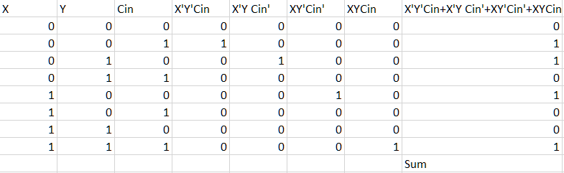

C out table-

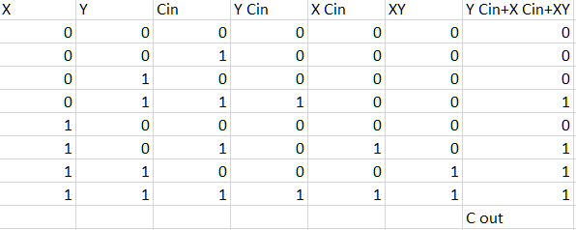

K-Maps:

Here are the two K-maps for the circuit. The Sum K-map has no grouping. It also oscillates in between values. The Cout K-map has three groupings, forming a T shape. These K-maps were verified by logisim and a friend.

Sum-

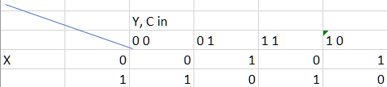

C out-

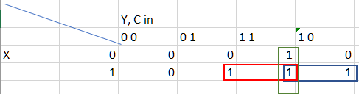

Logisim Circuit:

The circuit below shows thee 1-bit adder as well as the 3-bit adder built using the 1-bit adders. The 1-bit adder consisted of 7 AND gates and 2 OR gates. The 3-bit adder has an LED on the Sum1, Sum2, and Sum3. These LEDs show when the circuit is passing 1 through or 0 through. The simulation mode helped me to test out the circuits. When tested, the circuits seemed to function properly.

1-Bit Adder- 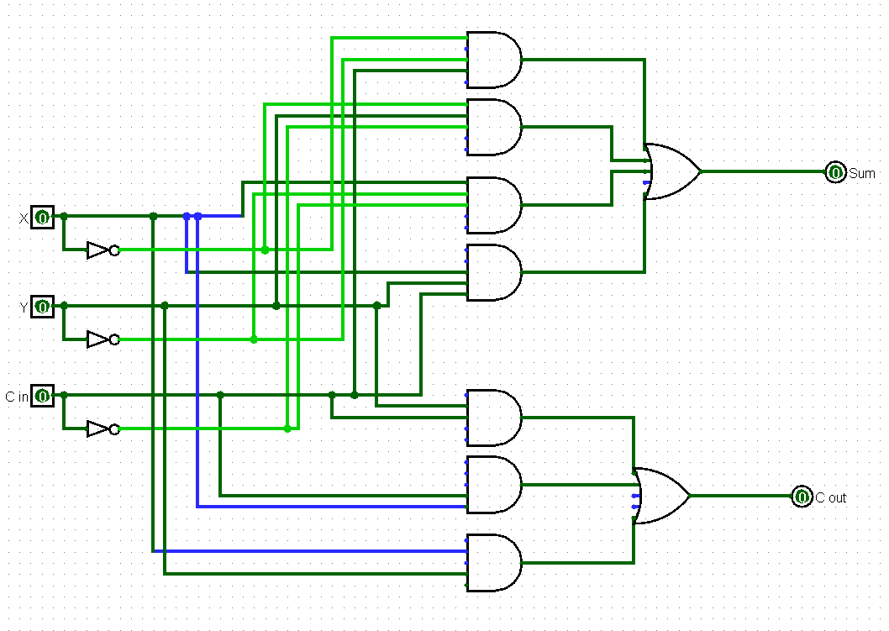3-Bit Adder-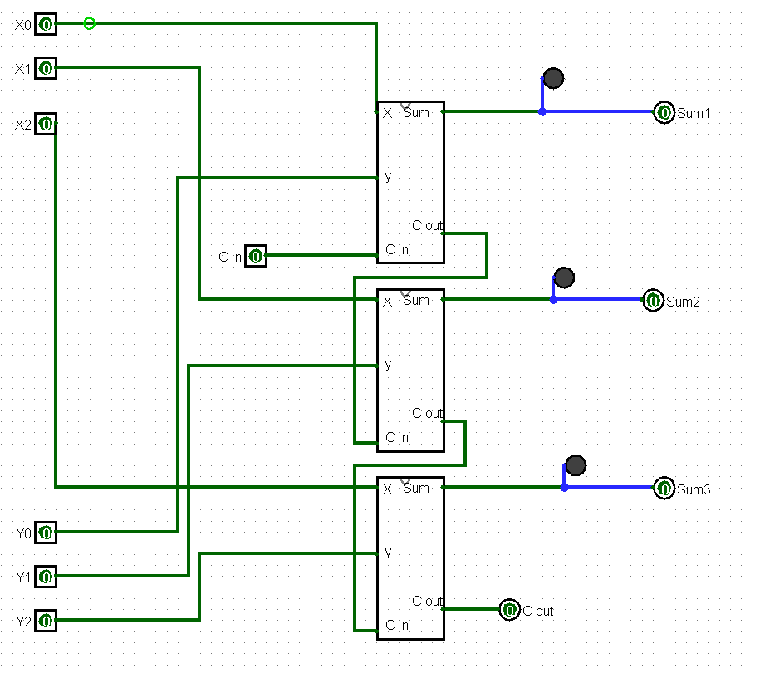

Simulation-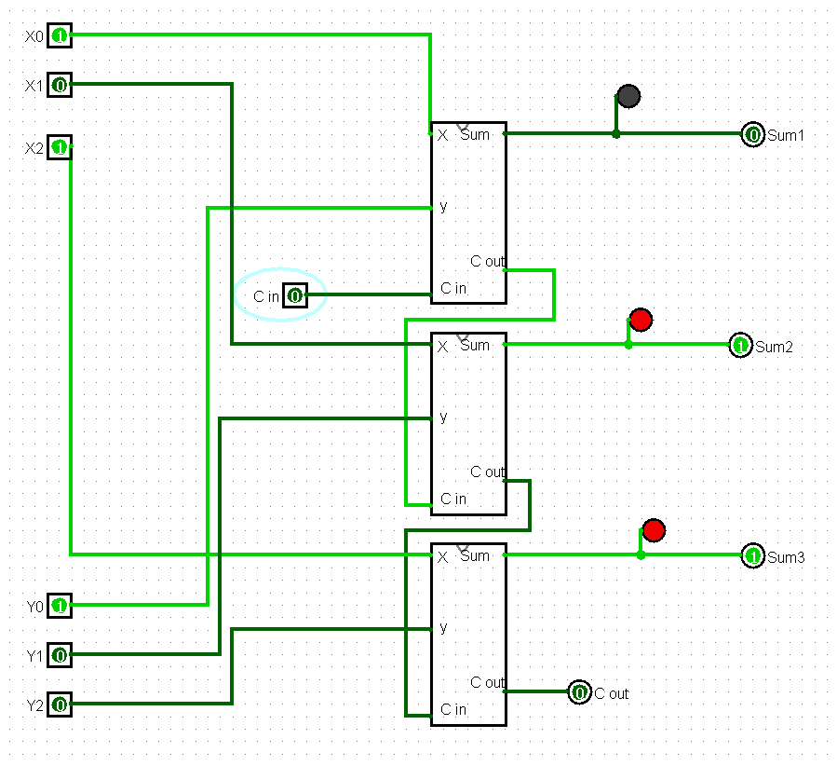

Conclusion:

I really enjoyed this project. It gave me a look at the scale of what can be done using logisim. On top of this, I better reinforced my skills with truth tables and K-maps. While doing this project, I had consulted with a friend of mine. We were both unsure about parts of the project but helped each other out wherever we could. I did not know how to wire up the three 1-bit adders, but my friend helped to guide me through the process. I enjoyed being able to turn on simulation and seeing everything changing with the click of a button. This project helped to teach me more about how logisim functions and about how circuits can be added together to perform different functions.   
  
 I am still a bit unsure with a few things. While this project has improved my K-mapping skills, I have a long way to go until I can perfect them. Also with logisim, I have gained an understanding of what AND, NOT, and OR gates do but looking through the program, there is a lot more to learn. These skills feel like they will be improved over time, but this project has rid of some of my doubts about the class.